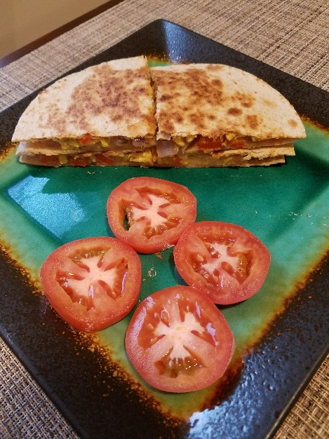
Ingredients:
2 egg whites plus one egg yolk
¼ cup shredded cheese (cheddar or Italian Style as shown)
2 6-inch whole wheat flour tortillas
1 medium red or yellow bell pepper
1 medium red or yellow onion
1 small tomato (for garnish)
1/8 tsp of Mrs Dash Table blend or spice blend of choice
½ tsp of canola or avocado oil
Cooking spray

Breakfast Quesadillas
(Serves 1)
Instructions:
Wash and dry fresh produce
Small dice ¼ of onion and ½ of bell pepper
Pre heat skillet on medium heat
Once skillet is hot, add ½ tsp of canola oil and swirl to coat pan
Cook peppers and onions till desired tenderness (I like mine semi-crunchy)
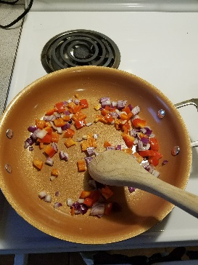
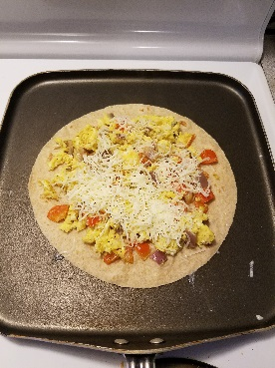
While vegetables are cooking whisk two egg whites and an egg yolk together in a small bowl adding 1/8 tsp of seasoning mix
Add egg to veggie mix in skillet and stir until all egg is cooked
Set egg mix to side in skillet and pre heat a griddle pan or another skillet big enough to hold tortilla shell
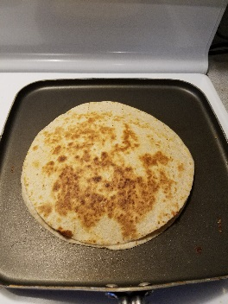
Spray griddle with cooking spray and once pan is hot, add 1 tortilla shell
Put egg mix on tortilla shell, add ¼ cup of cheese and cover with other tortilla shell
Let cook until cheese is melted, be sure to flip so the other side can cook!
Cut into fourths and plate with sliced tomato on the side
Nutrition Information
Calories: 515 Protein: 29g Total Carbohydrates: 44g Fat: 21g Saturated: 4g Unsaturated: 6g Sodium: 892mg

